**Title:** Date: 29-08-2018

Investigation on CO2 rebreathing risk in bubble CPAP breathing circuit.

**Background and Problem statement:**

It is observed that in some bubble CPAP devices where submersion bottle is at the inspiratory limb of the breathing circuit, a leakage resistor is introduced at the end of expiratory limb in order to eliminate the risk of CO2 rebreathing. But in addition, it makes the device pressure-unstable. The leakage resistor works in such a fashion that when the overall fresh airflow through the breathing circuit is lesser, the amount of leakage through the resistor is comparatively higher and vice versa. The relation between the flow-rate of fresh air and pressure is also non-linear unlike the conventional bubble CPAP systems. The submersion depth is also affected by the additional hardware & it can no longer be used to adjust the PEEP level alone. In this experiment we will try to find out CO2 accumulation in the breathing circuit in order to verify the significance and requirement of the leakage resistor.

**Hypothesis:**

Bubble CPAP devices with looped nasal cannula (bi directional breathing probe) is not prone to CO2 rebreathing phenomena & does not require a leakage resistor or bleed valve to eliminate the same.

**Materials:**

In this experiment the following materials are used

* Lattice Bubble CPAP device (under development)
* Airtight container for sensor placement & CO2 accumulation.
* Connectors & tubing for the accumulator bottle
* Data acquisition system (micro-controller, python code & libraries attached)
* 2 nos. MQ-135 CO2 sensor for ambient & in-circuit CO2 measurement

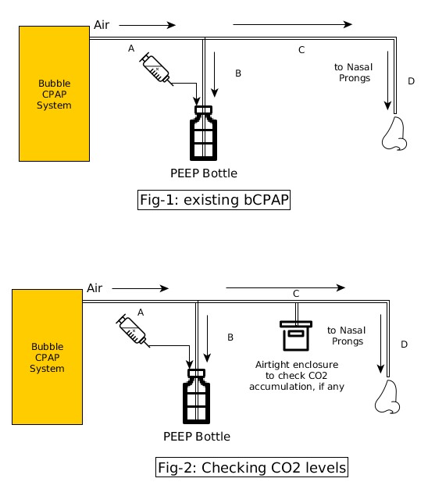

**Procedure:**

Bubble CPAP device has an external submersion bottle and a looped Nasal cannula. A T-joint (for tube ID 3/8”) is introduced in the breathing circuit by cutting the tube (ID 3/8”). An airtight container is added through the T joint & tube length is 150mm (ID 3/8”). One MQ-135 sensor is placed inside the container to check the CO2 level inside the circuit & another MQ-135 sensor is placed outside the circuit to capture the ambient CO2 levels. The data acquisition system consists of a microcontroller platform to interpret the data received from the sensor & feed the data to a PC usb port & a python code that logs the received data into a .csv file.

Three conditions are checked using this setup. (a)No-breathing, (b)Normal breathing and (c)Forced-breathing. No breathing simulator is used in this experiment & all the data has been generated while actually breathing through the circuit taking the leakage between the nostrils & nasal prongs under consideration which is a practical scenario. Data acquisition frequency is 1Hz per dataset (ambient and in-circuit value of CO2). Flow: 4lpm, Peep: 6 cm H2O

**Data:**

Relative curve for ambient and in-circuit CO2 is plotted against the acquired data.



In no-breathing condition, the CPAP is pushing fresh air through the circuit & the air is entirely exhaust through the nasal prong with no breathing through the nasal prong end.



In normal breathing condition, the nasal prong is placed at the nostrils of a human subject considering the leakage area between the nostrils & nasal prongs in order simulate the actual breathing condition with the bubble CPAP system.



In forced breathing condition, the setup is exactly same as the normal breathing phenomena except for the leakage which is entirely eliminated & there is no place left between the nostrils & nasal prongs so that the entire expiration can happen through the breathing circuit only. The expired CO2 is forcefully exhausted through the submersion bottle.

**Analysis:**

During the experiment the CO2 level is found to be below the specified safety[1] [2] levels.

At the beginning of the experiment, in no-breathing condition the CO2 level inside the container is gradually decreased and it is also observed that it takes almost 30 minutes to get stabilized.

In the second instance of the experiment, bubble CPAP is used in breathing. To replicate the actual use case, this experiment is done with human subject & the provision of leakage between nostrils & nasal prongs is left as it is. The experiment result shows no significant change in the in-circuit CO2 levels. In the designed bubble CPAP system, there are two pressure acting at the tip of the nasal prong. Pressure exerted by the bubble CPAP (**Pa**) system & pressure exerted by the infant (**Pb**) during exhalation. 

The forced breathing condition was fulfilled by covering any gap between the prong & nostrils. Entire exhaled gas is thus drained through the submersion bottle. In that case the average CO2 level inside the circuit increases over a very short period of time but as the results show, the CO2 level gets stabilized over time & settled at around 250 ppm which is again found to be below the stated safety[1] [2] levels.

**C**ontinuous **P**ositive **A**irway **P**ressure, the name itself suggests that the pressure exerted from the nasal cannula is higher than the exhalation pressure of the patient availing the CPAP support for breathing, and by definition **(Pa) > (Pb).** In that case, air exhaled by the patient theoretically cannot enter the breathing circuit unlike bi-PAP systems.

There are two different types of breathing probes.

1. With an end-cap (bleed resistor may include) and separate inspiratory & expiatory limb

2. Looped nasal cannula with no dedicated inspiratory & expiratory limb.

In the end cap type probes, there can be an accumulation of gases since the space between nasal prong & end cap is filled with dead air. Only the inspiratory limb is significant for the breathing application, expiratory limb can be used as a support system for holding the nasal probes properly in place. This design also demands an additional hardware (bleed valve) to eliminate the accumulated gases from the breathing circuit. 

Looped nasal cannula can have a number of advantages over cannula with separate inspiratory & expiratory limb. The absence of an expiratory limb entitles the ram cannula to be dead-space free. The entire air-flow is exhausted through the nasal cannula since air is coming from both sides of the nasal prong. 

**Conclusion:**

Looped nasal prongs stands out to be most useful for avoiding dead space & CO2 contamination which is very unlikely in conventional Bubble CPAP systems. It also has the advantage of pressure stability of the overall PEEP & flow rate. Thus we may conclude that the requirement of leakage resistor is not necessary for systems where looped nasal cannula is used.

*References:*

1. <https://www.kane.co.uk/knowledge-centre/what-are-safe-levels-of-co-and-co2-in-rooms>
2. <https://www.engineeringtoolbox.com/co2-comfort-level-d_1024.html>